Y6 Autumn Curriculum

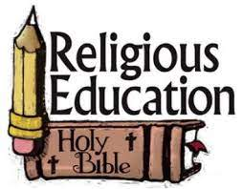 | Y6 themes in RE will be: Domestic Church - God who never stops loving  Baptism/Confirmation - VOCATION AND COMMITMENT - The vocation of priesthood and religious life  Hinduism - Belongings and values  Advent/ Christmas - EXPECTATIONS - Jesus born to show God to the world
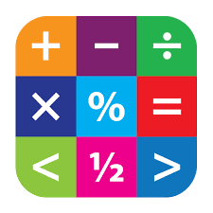 | In Maths Y6 will be extending their skills in the following: Place Value, Addition and Subtraction, Multiplication and Division
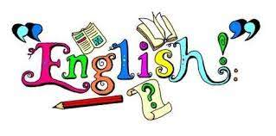 | In English Y6 will have the opportunity to read various texts to extend their skills of understanding, vocabulary & inference.  In writing Y6 will explore texts and have lots of writing opportunities to create a flashback story and an explanation text.
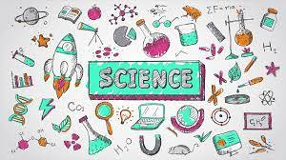 | In Science Y6 are looking at Living Things and their habitats and Animals including humans.
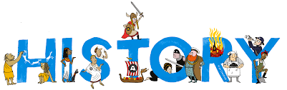 | In History Y6 will be learning about The Transatlantic Slave Trade.
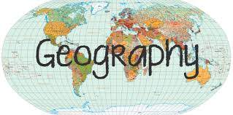 | In Geography Y6 will be learning about different climate zones
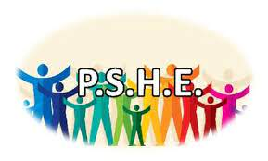 | In PSHE Y6 will be involved with the following:  School council elections & interviews; Class charter; Black History Month & Standing up to discrimination; Promoting diversity; Physical & Social relationships; First Aid; Guy Fawkes & Halloween: keeping safe; Rights respecting school activities; Bush Craft; British Values
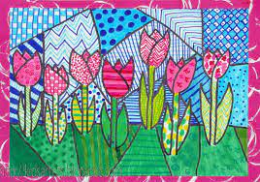 | In Art Y6 will be exploring artwork inspired by Dominic Hinchliffe
 | In DT Y6 will be investigating food and nutrition to celebrate culture and seasonality.
 | In music Y6 will be using drums and glockenspiel percussion instruments to explore rhythm and perform compositions.
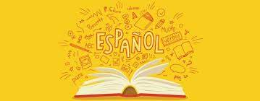 | In Y6 the children will learn Spanish in the following areas: Family + job Feelings (hot/cold/thirsty etc) At the doctors (dialogue) Recall 1-100 (x10 – 100 RRP)
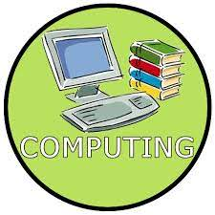 | In Computing Y6 will be looking at communication and collaboration using technology and begin website designing.
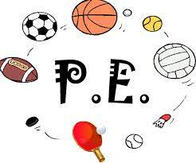 | In PE Y6 are focusing on dance and football.

