Y6 Spring Curriculum

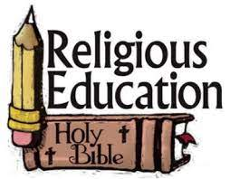 | Y6 themes in RE will be: Domestic Church - God who never stops loving  SOURCES - The Bible, the special book for the Church. UNITY - Eucharist enabling people to live in communion. DEATH & NEW LIFE - Celebrating Jesus’ death and resurrection.
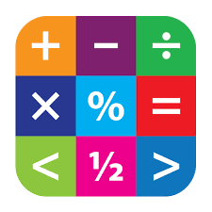 | In Maths Y6 will be extending their skills in investigations and project work
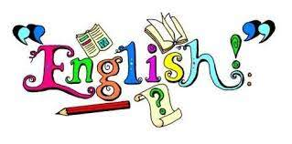 | In English Y6 will have the opportunity to read various texts to extend their skills of understanding, vocabulary & inference.  In writing Y6 will explore texts and have lots of writing opportunities to create classic fiction story, a discussion and an explanation text.
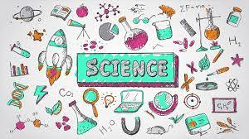 | In Science Y6 are looking at Electricity
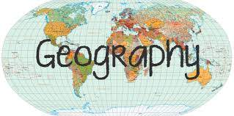 | In Geography Y6 will be learning about how to protect our world and natural resources (Our Interconnected World).
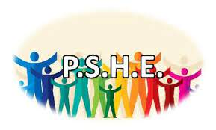 | In PSHE Y6 will be involved with the following:  A Journey In Love– Physical One Decision – Worry No Outsiders – To overcome fears about difference, One Decision– Making Friends Online and to consider causes of racism and PATHS
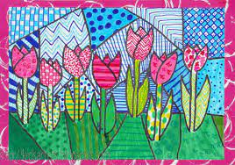 | In Art Y6 will be exploring portraits inspired by Hundertwasser.
 | In DT Y6 will be investigating Fashions and designers over time in tops. They will be making recycled clothes and fashion show
In music Y6 will be focusing on the topics:
Benjamin Britten - A New Year Carol Style: Benjamin Britten (Western Classical Music), Gospel, Bhangra.
Happy Style: Pop/Motow
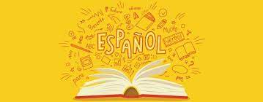 | In Y6 the children will learn Spanish in the following areas: Places in town and directions Round numbers up to 1,000,000 1 1,000 (R/W) Haunted castle mystery Prepositions Counting x2, x3, x5, x10 Fractions and decimals
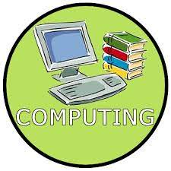 | In Computing Y6 will be building and testing a virtual robot & and creating a Heroes and Villains style game using the program Scratch.
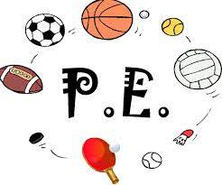 | In PE Y6 are focusing on handball and tennis.

