Y6 Summer Curriculum

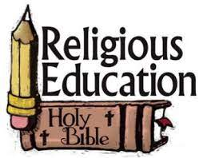 | Y6 themes in RE will be: Domestic Church - God who never stops loving  WITNESSES - The Holy Spirit enables people to become witnesses  HEALING - Sacrament of the Sick  COMMON GOOD – Work of the worldwide Christian family
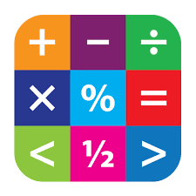 | In Maths Y6 will be extending their skills in investigations and project work
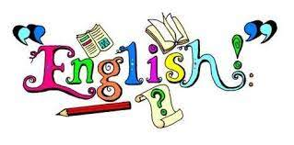 | In English Y6 will have the opportunity to read various texts to extend their skills of understanding, vocabulary & inference.  In writing Y6 will explore texts and have lots of writing opportunities to create classic fiction story, a discussion and an explanation text.
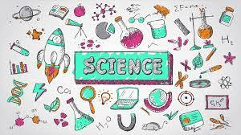 | In Science Y6 are looking at Electricity and light
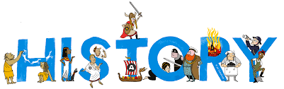 | In History Y6 will be learning about the civil and human rights icons
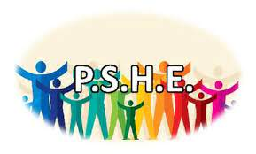 | In PSHE Y6 will be involved with the following:  A Journey In Love– Spiritual,  One Decision – in-app purchases and British Values  No Outsiders – Showing acceptance and democracy
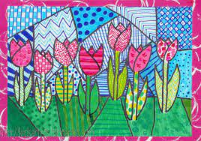 | In Art Y6 will be exploring sculpture designed and made by Zaha Hadid
 | In DT Y6 will be investigating Fashions and designers over time in tops. They will be making recycled clothes and fashion show
In music Y6 will be focusing on the topics:
Unit: You've Got A Friend
Style: The Music of Carole King
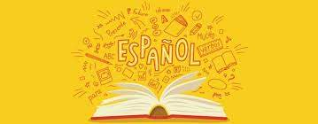 | In Y6 the children will learn Spanish in the following areas: Places in town and directions Round numbers up to 1,000,000 1 1,000 (R/W) Haunted castle mystery Prepositions Counting x2, x3, x5, x10 Fractions and decimals
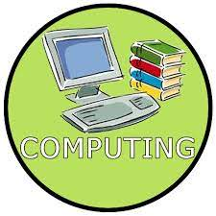 | In Computing Y6 will be learning about stocks and shares, coding and Apps.
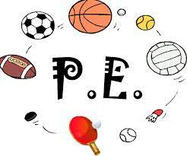 | In PE Y6 are focusing on Athletics and football

